Test
Images exported from Sangala Blocks "Test".
Step 1
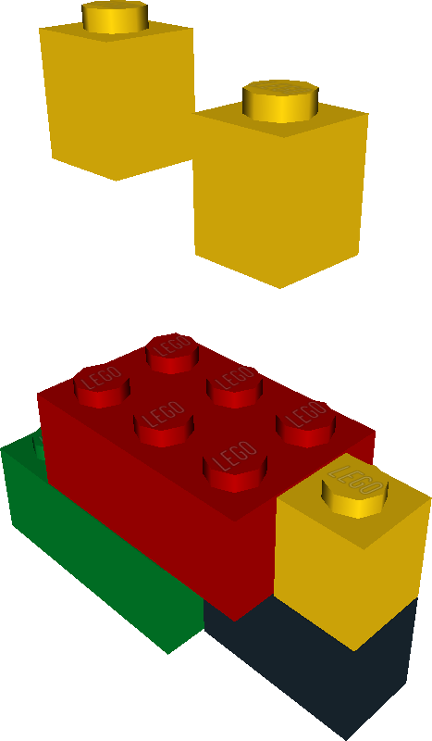

Step 2


